**DIRECT AND INDIRECT SPEECH**

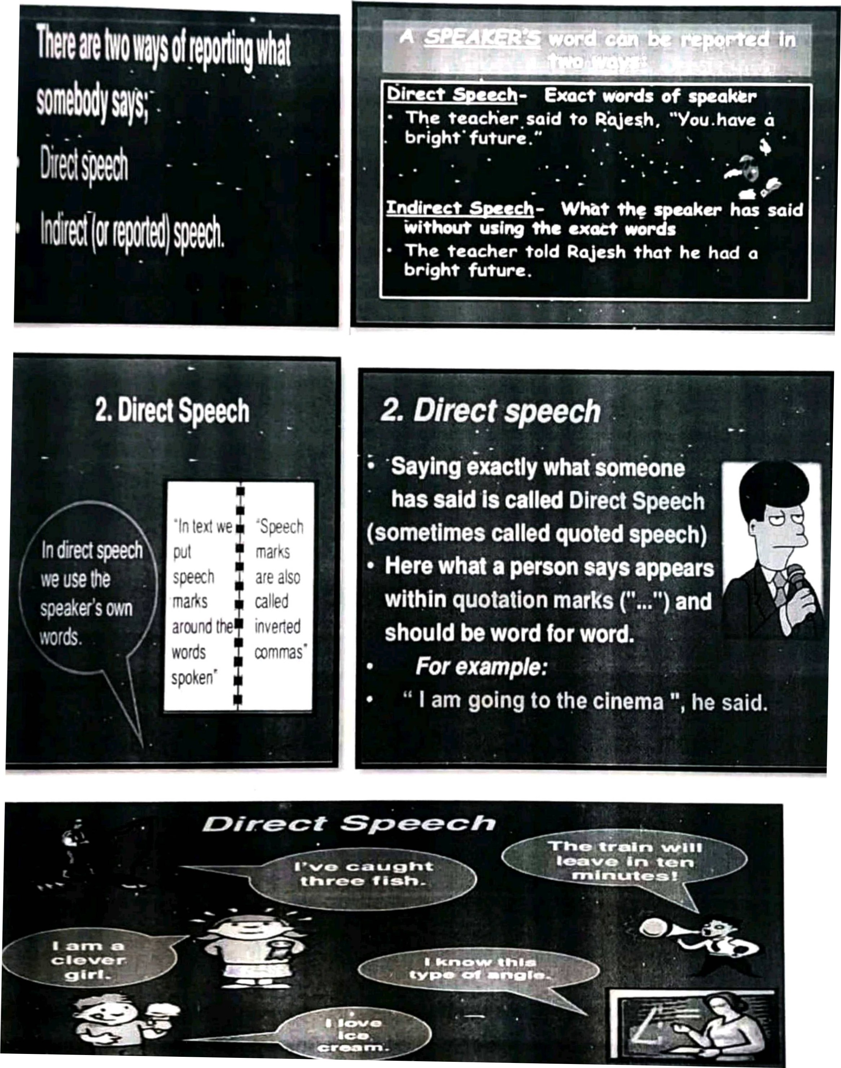

**WHAT IS DIRECT &INDIRECT SPEECH?**

* Direct speech reporting the message of the speaker in the exact words as spoken by him.
* Direct speech example: Maya said 'l am busy now'.
* Indirect speech: reporting the message of the speaker in our own words
* Indirect speech example: Maya said that she was busy then.

|  |  |  |
| --- | --- | --- |
| Rules | Direct speech | Indirect speech |
| **Rule 1:** All the present tenses are  changed to the corresponding past tense in indirect speech. | She said, 'l am happy'. | She said that she was happy. |
| **Rule 2:** Present Perfect Changes to Past Perfect. | have been to Boston", she told me. | She told me that she had been to Boston. |
| **Rule 3:** Present Continuous Changes to Past Continuous | I am playing the guitar", she explained | She explained that she was playing the guitar. |
| **Rule 4**: Present Perfect Changes to Past Perfect | He said, "She has finished her homework". | He said that she had finished her homework. |
| **Rule 5:** Simple Past Changes to Past Perfect | She said, "Irvin arrived on Sunday." | She said that Irvin had arrived on Sunday. |
| **Rule 6:** Past Continuous Changes to Past Perfect Continuous | We were playing basketball", they told me. | They told me that they had been playing basketball. |
| **Rule 7:** Future Changes, to Present Conditional | She said, "l will be in  Scotland tomorrow." | She said that she would be in Scotland the next day. |



# **ll. Direct Speech to Indirect Speech Conversion — Interrogative Sentences**

1. **Direct:** "Where do you live?" asked the boy.
2. **Indirect:** The boy enquired where I lived.
3. **Direct**: She said, 'Will you come for the party'?
4. **Indirect**: She asked whether (OR) if she would come for the party.
5. **Direct:** He said to me, 'What are you wearing'?
6. **Indirect:** He asked me what I was wearing.

# **Ill. Direct Speech to Indirect Speech Conversion — Changes in Modals**

While changing direct speech to indirect speech, the modals used in the sentences change like:

* **Can** becomes **could**
* **May** becomes **might**
* **Must** become **had to /would have to**

Examples:

* **Direct:** She said, 'She can dance'.
* **Indirect:** She said that she could dance.
* **Direct:** She said, 'l may buy a dress'.
* **Indirect:** She said that she might buy a dress.
* **Direct**: Rama said, 'l must complete the assignment'.
* **Indirect:** Rama said that he had to complete the assignment.

**IV. Direct Speech to Indirect Speech Conversion — Request, Command, Wish, Exclamation.**

Indirect Speech is supported by some verbs like **requested, ordered, suggested and advised.** **Forbid-forbade** is used for negative sentences. Therefore, the imperative mood in the direct speech changes into the Infinitive in indirect speech.

1. **Direct:** She said to her 'Please complete it'.
2. **Indirect:** She requested her to complete it.
3. **Direct:** Hamid said to Ramesh, 'Sit down'.
4. **Indirect:** Hamid ordered Ramesh to sit down.
5. **Direct:** She said, 'Alas! We lost "
6. **Indirect:** she exclaimed sadly that they had lost.

# **Direct Speech to Indirect Speech Conversion — Change of Time**

In direct speeches, the words that express nearness in time or place are changed to words that express distance in indirect speech. Such as:

* **Now** becomes **then**
* **Here** becomes **there**
* **Ago** becomes **before**
* **Thus,** becomes **so**
* **Today** becomes **that day**
* **Tomorrow** becomes the **next day**
* **This** becomes **that**
* **Yesterday** becomes **the day before**
* **These** become **those**
* **Hither** becomes **thither**
* **Come** becomes **go**
* **Hence** becomes **thence**
* **Next week or month** becomes **following week/month**

**CHANGE THE FOLLOWING INTO INDIRECT SPEECH:**

1. He said, "I like this song."

**Ans:** He said that he liked that song.

2. "Where is your sister?" she asked me.

**Ans:** She asked me where my sister was.

3. "l don't speak Italian," she said.

**Ans**: She said that she didn't speak Italian.

4."Say hello to Jim," they said

**Ans:** They told me to say hello to Jim.

5. "The film began at seven o'clock," he said.

**Ans**: He said that the film had begun at seven o'clock.

6."Don't play on the grass, boys," she said.

**Ans:** She told the boys not to play on the grass.

7."Where have you spent your money?" she asked him.

**Ans:** She asked him where he had spent his money.

8."l never make mistakes," he said.

**Ans:** He said that he never made mistakes.

9. "Does she know Robert?" he wanted to know.

**Ans:** He wanted to know if she knew Robert.

10."Don't try this at home," the stuntman told the audience.

**Ans:** The stuntman told the audience not to try that at home

11.The girl said, 'It gives me great pleasure to be here this evening.'

**Ans:** The girl said that it gave her great pleasure to be there that evening.

12.The man said, 'l must go as soon as possible.'

**Ans:** The man said that he had to go as soon as possible.

13.She said, 'l don't want to see any of you; go away.'

**Ans:** She said that she didn’t want to see any of them and told them to go away.

14.The teacher says, 'If you work hard, you will pass.

**Ans:** The teacher says that if we work hard, we will pass.

15. He said, 'l have won.

**Ans:** He said that he had won.

16.He said, 'Let's wait for her return.

**Ans:** He suggested that they should wait for her return.

17.Alice said, 'How clever I am!

**Ans:** Alice said how clever she was.

18.'Which way did she go?' asked the young man.

**Ans:** The young man asked which way she had gone.

19.He said to me, 'Where are you going?

**Ans:** He asked me where I was going.

20.Please wait here till I return,' she told him.

**Ans:** She told him to wait there till she returned.

21.He says, "l am ill."

**Ans**: He says that he is ill.

22.She says, "She sang a song."

**Ans:** She says that she sang a song.

23.They said, "They take a walk every day."

**Ans:** They said that they took a walk every day.

24.She said, "I'm leaving tomorrow".

**Ans:** She said that she was leaving the next day.

25.He said, "Please get me a cup of tea

**Ans:** He asked me to get him a cup of tea.

26."It is too late to apologize," I said.

**Ans**: I said that it was too late to apologize.

27."l cannot come to your birthday party," explained Mary

**Ans:** Mary explained that she could not come to my birthday party.

28.I will finish this picture tomorrow," said Diana.

**Ans**: Diana said that she would finish that picture the next day.

29.'You will have to surrender your passport,' the officer said to the passenger.

**Ans:** The officer told the passenger that he would have to surrender his passport.

30.'l saw an interesting film last evening,' said my friend.

**Ans:** My friend said that he had seen an interesting film the previous evening.

**\*\*\*\*\*\*\*\*\*\*\*\*\*\*\*\*\*\*\*\*\*\*\*\*\*\*\*\*\*\*\*\*\*\***